Project Planning

For

HofSwap

Prepared by:

1. Parhum Ebrahimian
2. Frank Martin
3. Aishik Mallick
4. Joseph Gentile
5. Trey Jean-Baptiste

CSC190 Project

Spring 2020

Table of Contents

Cover Page—pg.1

Intro—pg. 3

Requirements Traceability—pg.3

Risk Level—pg. 4

Activity Graph—pg.4

Slack Chart—pg.5

Testing—pg. 6

Schedule—pg. 7

Config Management—pg. 7-8

Our app is meant to be used by Hofstra Students. Ideally every account will be able to buy and sell textbooks. When a buyer is ready to purchase, they will hit a button which will then reach out to a seller in order to make sure the seller is ready to sell and the book is still intact. Our app is NOT a marketplace, but more like an exchange platform for users to get in contact to each other and work out pricing and other details. Below is our Task chart and how we plan on finishing the app. Since we will be developing on iOS and Android OS, our

team will be taking the tasks one by one, but split into two teams; One developing for iPhone, the other for Android.

**Requirements Traceability**

|  |  |  |  |  |
| --- | --- | --- | --- | --- |
| # | TASK | Requirements Point | DURATION (weeks) | DEPENDENCIES |
| T1 | Login Page (Authentication) | 1.1 | 1 | T9 |
| T2 | Sign up View | 1.2 | 1 | T1 |
| T3 | Profile Page | 2, 2.1, 2.2 | 2 | T1, T2 |
| T4 | Notification | 6 | 1 | T3 |
| T5 | Upload page | 3 | 1 | T9 |
| T6 | Search page | 4, 4.1, 4.2, | 1 | T9 |
| T7 | Detailed View | 5, 5.1, 5.2, 6 | 1 | T8, T6 |
| T8 | Amazon functions | 8 | 2 | - |
| T9 | Firebase implementation | 7 | 2 | - |

CRITICAL PATH: T9, T1, T3, T4

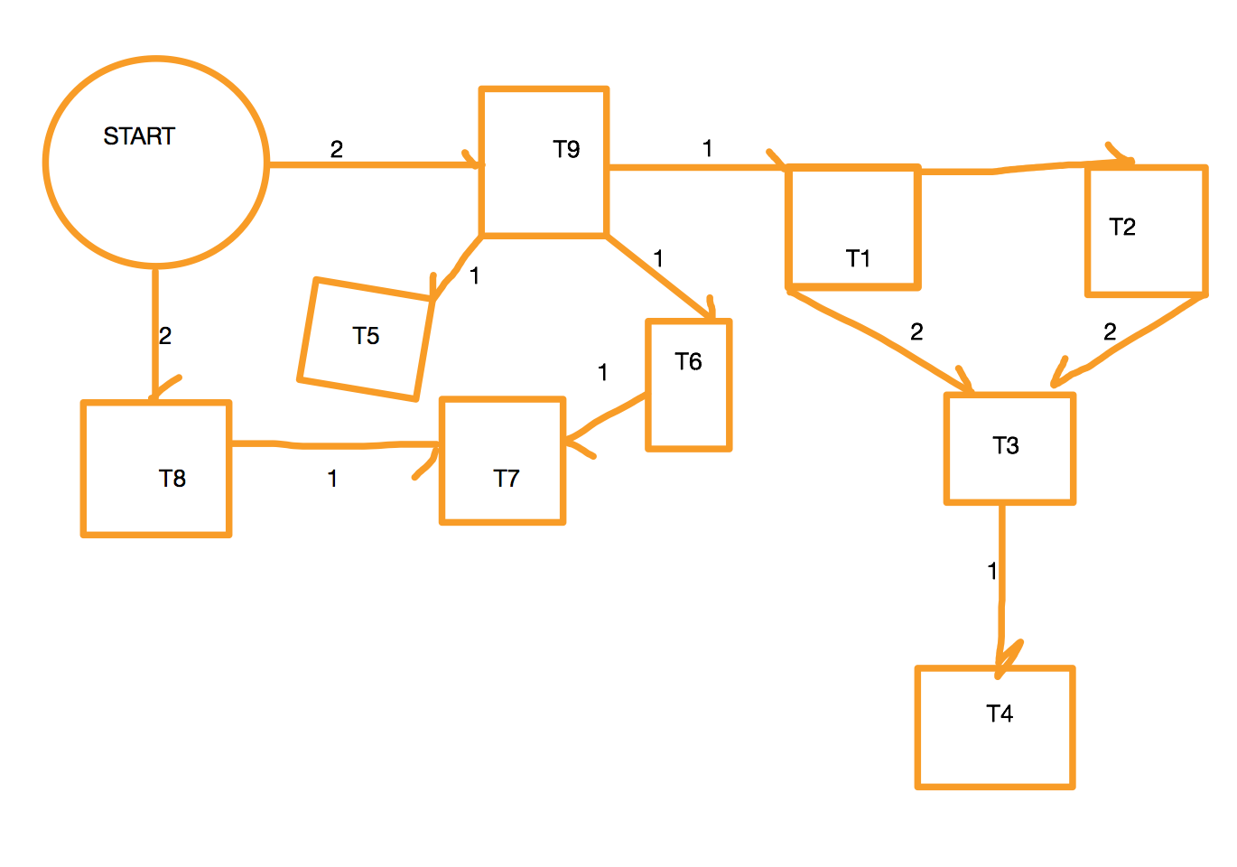

|  |  |
| --- | --- |
| **Risk level** | **Tasks** |
| High Risk | T9, T8, |
| Medium Risk | T6, T7, T3, |
| Low Risk | T5, T4, T2, T1 |

|  |  |
| --- | --- |
| T9  Earliest Start: 0  Earliest Finish: 2  Latest Start: 0  Latest Finish: 2  Slack: 0 | T1  Earliest Start: 2  Earliest Finish: 3  Latest Start: 2  Latest Finish: 3  Slack: 0 |
| T2  Earliest Start: 3  Earliest Finish: 4  Latest Start: 3  Latest Finish: 4  Slack: 0 | T3  Earliest Start: 4  Earliest Finish: 6  Latest Start: 4  Latest Finish: 6  Slack: 0 |
| T4  Earliest Start: 6  Earliest Finish: 7  Latest Start: 6  Latest Finish: 7  Slack: 0 | T8  Earliest Start: 0  Earliest Finish: 2  Latest Start: 4  Latest Finish: 6  Slack: 2 |
| T7  Earliest Start: 3  Earliest Finish: 4  Latest Start: 6  Latest Finish: 7  Slack: 3 | T5  Earliest Start: 2  Earliest Finish: 3  Latest Start: 6  Latest Finish: 7  Slack: 4 |
| T6  Earliest Start: 2  Earliest Finish: 3  Latest Start: 5  Latest Finish: 6  Slack: 3 |  |

**TESTING/ Quality Assurance**

1. Development Testing
   1. Each person will test their specific module
   2. Unit Testing
      1. Login Page-
      2. Signup View-
         1. Create a new user; Check if log-in is successful using dummy data, access database to see if new user is there
      3. Notification page-
         1. send seller message as a buyer to see if notifications show up
      4. Upload Page-
         1. Upload textbooks using the database and check if it is there
      5. Search page
         1. Search for multiple books with the location known to us
      6. Detailed View
         1. Check for the status of the book and its condition with our own data
      7. Amazon and Firebase
         1. Check API calls and its compatibility with what code we have
   3. System Testing
      1. Once every component is working individually we will link everything together, it’s important to see the system working together.
   4. Release Testing
      1. Make sure entire system is working flawlessly before release

**SCHEDULE**

|  |  |  |  |  |  |  |  |  |  |
| --- | --- | --- | --- | --- | --- | --- | --- | --- | --- |
|  | Week1 | Week2 | Week3 | Week4 | Week5 | Week6 | Week7 | Week8 | Week9 |
| P | T9 | T9 | T2 | T3 | T3 | T4 | TEST | TEST | TEST |
| A | T9,T8 | T9,T8 | T6 | T5 | T3 | T4 | TEST | TEST | TEST |
| J | T8 | T8 | T2,T6 | T3 | T3 | T4 | TEST | TEST | TEST |
| F | T8 | T1 | T2 | T5 | T7 | T4 | TEST | TEST | TEST |
| T | T9 | T1 | T6 | T3 | T7 | T4 | TEST | TEST | TEST |

|  |  |  |  |  |  |  |  |  |  |
| --- | --- | --- | --- | --- | --- | --- | --- | --- | --- |
|  | Week1 | Week2 | Week3 | Week4 | Week5 | Week6 | Week7 | Week8 | Week9 |
| TESTING | - | T9,T8 | T1 | T2 | T6,T2 | T3,T5 | T4 | SYSTEM | SYSTEM |

**CONFIGURATION MANAGEMENT**

1. Version management:
2. Github platform: will be following a Github branch hierarchy containing the following branches:
3. Consumer ready branch: main version ready for the consumer to use.
4. Updated branch: branch containing new updated versions of the software.
5. Creation branch: branch reserved for the sole purpose of development.

* Will be utilizing pull requests to merge branches

1. System management: Will be using Amazon firebase to assemble libraries, data, and program components.

C. Change management: any changes made will be recorded on Github. As a second alternative we will be listing all changes made on a separate file.